**c. Bug:** Odds in the game do not appear to be correct.

**Description:** Crown and Anchor games have an approximate 8% bias to the house. So thewin :(win+lose) ratio should approximately equal 0.42. This does not appear to be the case.

**Reproducing bug:** On executing code below output is generated,

**Screenshots:** Initial state of variables

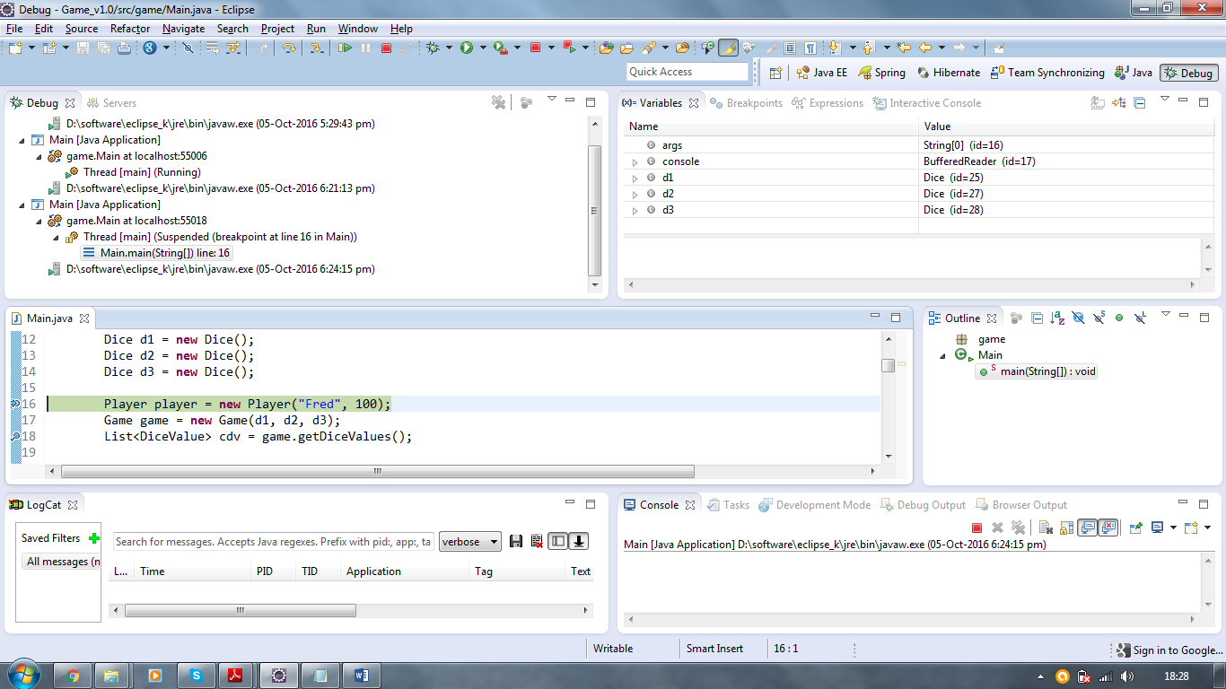

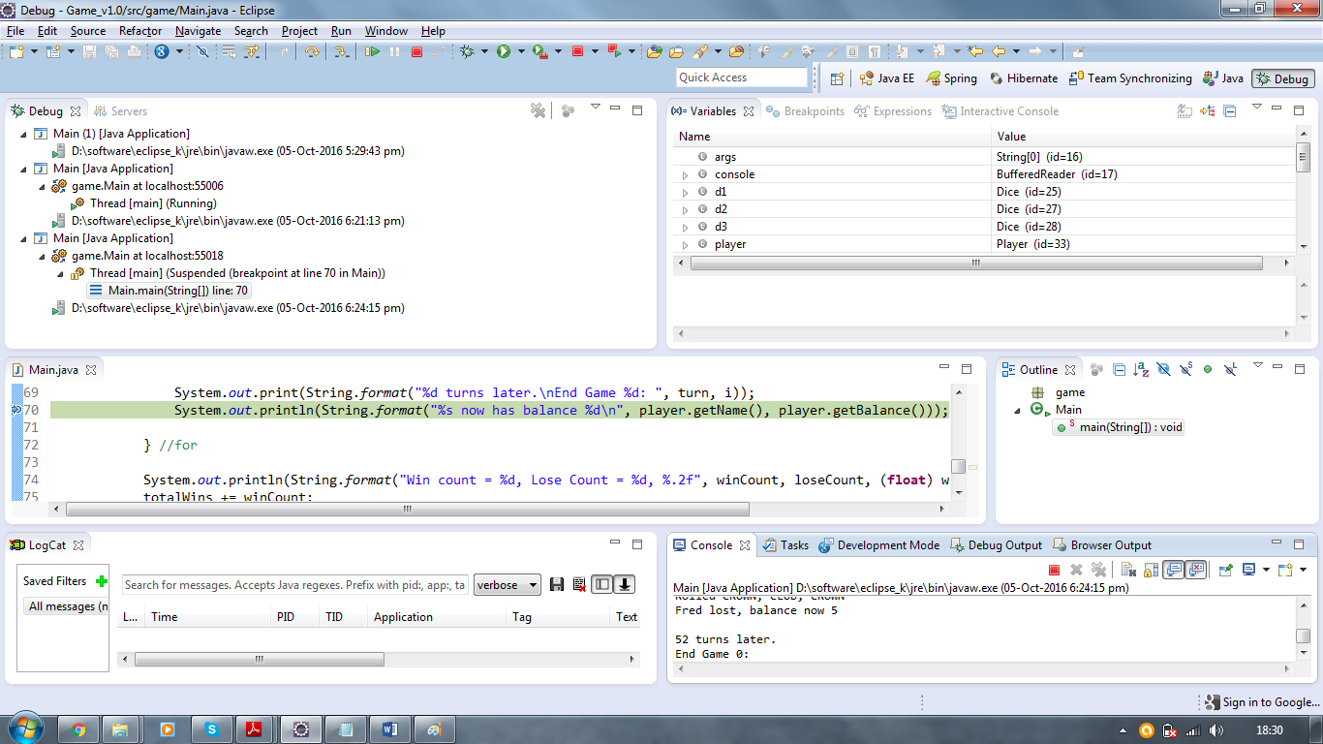

**Win : (win + lose) ration is 0.60**

